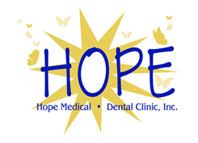HOPE MEDICAL CLINIC, INC.
Free Non-Emergency Medical Consultations
1125 Forrest Avenue, Suite 202, Dover, DE 19904- PH: (302)735-7551 (F) (302)735-4746

PERSONAL HEALTH INFORMATION CONSENT
The purpose of this consent form is to inform you how your personal health information is used and/or disclosed by this provider or organization.
A. You CONSENT:
I understand that as part of my health care, this organization originates and maintains health records describing my health history, symptoms, test results, diagnoses, treatment, and plans for future care.
I understand that this information serves as:

1. A basis for planning my care and treatment.
2. A means of communication among the many health professionals
who contribute to my care.
3. A tool for routine health care operations in this organization, such as
ensuring that we have quality processes and programs in place and
making sure that the professionals who provide your care are
competent to do so.

B. RESTRICTIONS:
You have the right to request restrictions as to whom and how your health information may be disclosed (i.e, family members, insurances, research).
I understand that the consultations and treatment provided through the Hope Medical Dental Clinic, Inc. at the Modern Maturity Center in Dover, DE are free of charge, acting on the premise of Good Samaritan Services. I do hereby release them from any and all legal responsibility by doing so.
I certify that my medical history contained herein is true and any false statements will disqualify me from their services.

Patient Name: ___________________________________________

Patient Signature: ___________________________________________
Date: ___________________________________________

